9.Frequent itemset using apriori
#APRIORI
import pandas as pd
from mlxtend.preprocessing import TransactionEncoder
from mlxtend.frequent_patterns import apriori, association_rules
# Sample transaction data
transactions = [
['milk', 'bread', 'eggs'],
['milk', 'bread'],
['milk', 'eggs'],
['bread', 'eggs'],
['milk', 'bread', 'eggs', 'butter'],
['bread', 'butter']
]
# Convert transactions into a one-hot encoded DataFrame
te = TransactionEncoder()
te_ary = te.fit(transactions).transform(transactions)
df = pd.DataFrame(te_ary, columns=te.columns_)
# Generate frequent itemsets using Apriori algorithm
frequent_itemsets = apriori(df, min_support=0.5, use_colnames=True)
# Generate association rules based on confidence
rules = association_rules(frequent_itemsets, metric="confidence", min_threshold=0.7)
# Display results
print("Frequent Itemsets:")
print(frequent_itemsets)
print("\nAssociation Rules:")
print(rules[['antecedents', 'consequents', 'support', 'confidence', 'lift']])

Output:
Frequent Itemsets:
support itemsets
0 0.833333 (bread)
1 0.666667 (eggs)
2 0.666667 (milk)
3 0.500000 (bread, eggs)
4 0.500000 (milk, bread)
5 0.500000 (milk, eggs)
Association Rules:
antecedentsconsequents support confidence lift
0 (eggs) (bread) 0.5 0.75 0.900
1 (milk) (bread) 0.5 0.75 0.900
2 (milk) (eggs) 0.5 0.75 1.125
3 (eggs) (milk) 0.5 0.75 1.125

10.Chi-Square
import numpy as np
def calculate_chi_square(observed, expected):
observed = np.array(observed)
expected = np.array(expected)
chi_square = np.sum((observed - expected) ** 2 / expected)
return chi_square
# Observed and expected frequencies
observed_values = [10, 15, 20, 25]
expected_values = [12, 15, 18, 25]
# Calculate chi-square value
chi_square_value = calculate_chi_square(observed_values, expected_values)
# Display result
print(f"The chi-square value is: {chi_square_value}")
Output: The chi-square value is: 0.5555555555555556
11. Naïve Bayesian
from sklearn.datasets import load_iris
from sklearn.model_selection import train_test_split
from sklearn.naive_bayes import GaussianNB
from sklearn.metrics import accuracy_score, classification_report
iris = load_iris()
X = iris.data
y = iris.target
X_train, X_test, y_train, y_test = train_test_split(X, y, test_size=0.3, random_state=42)
model = GaussianNB()
model.fit(X_train, y_train)
y_pred = model.predict(X_test)
print("Accuracy:", accuracy_score(y_test, y_pred))
print("\nClassification Report:\n", classification_report(y_test, y_pred))
output:
Accuracy: 0.9777777777777777
Classification Report:
precision recall f1-score support

0 1.00 1.00 1.00 19
1 1.00 0.92 0.96 13
2 0.93 1.00 0.96 13

accuracy 0.98 45
macro avg 0.98 0.97 0.97 45
weighted avg 0.98 0.98 0.98 45

13.simple K-means
#CLUSTERING SIMPLE K-MEANS
import numpy as np
import matplotlib.pyplot as plt
from sklearn.cluster import KMeans
data = np.array([
[1.0, 1.0],
[1.5, 2.0],
[3.0, 4.0],
[5.0, 7.0],
[3.5, 5.0],
[4.5, 5.0],
[3.5, 4.5]
])
kmeans = KMeans(n_clusters=2, random_state=0)
kmeans.fit(data)
labels = kmeans.labels_
centroids = kmeans.cluster_centers_
plt.figure(figsize=(8, 6))
plt.scatter(data[:, 0], data[:, 1], c=labels, cmap='viridis', marker='o')
plt.scatter(centroids[:, 0], centroids[:, 1], c='red', marker='x', s=100, label='Centroids')
plt.title('K-Means Clustering Result')
plt.xlabel('X')
plt.ylabel('Y')
plt.legend()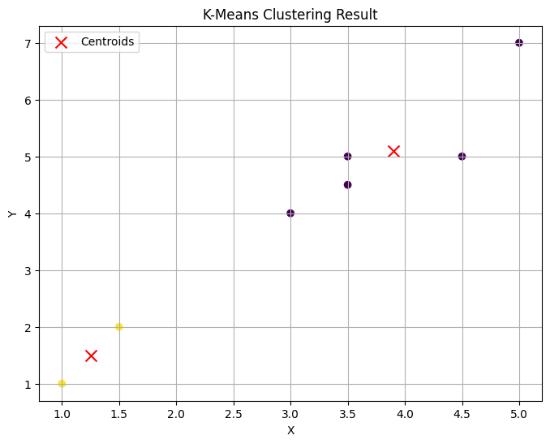
plt.grid(True)
plt.show()

14.cluster analysis k-means
#KMEANSANALYSIS
import pandas as pd
from sklearn.cluster import KMeans
import matplotlib.pyplot as plt
from sklearn.datasets import load_iris
iris = load_iris()
data = pd.DataFrame(iris.data, columns=iris.feature_names)
kmeans = KMeans(n_clusters=3, random_state=42)
data['Cluster'] = kmeans.fit_predict(data)
plt.figure(figsize=(6, 6))
plt.scatter(data['sepal length (cm)'], data['sepal width (cm)'], c=data['Cluster'], cmap='viridis', s=50)
plt.title('K-Means Clustering of Iris Data')
plt.xlabel('Sepal Length')
plt.ylabel('Sepal Width')
plt.grid(True)
plt.show()
output:
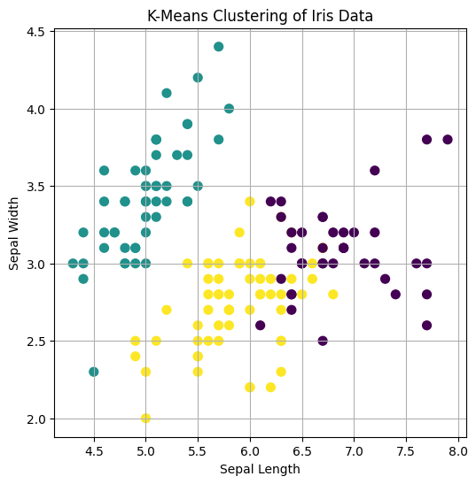
15. dissimilarity matrix
import numpy as np
from scipy.spatial.distance import pdist, squareform
data = np.array([
[2.0, 3.0],
[3.5, 5.0],
[1.0, 2.0],
[4.0, 4.5]
])
dissimilarity_matrix = squareform(pdist(data, metric='euclidean'))
print("Dissimilarity Matrix (Euclidean Distance):")
print(dissimilarity_matrix)
output:
Dissimilarity Matrix (Euclidean Distance):
[[0. 2.5 1.41421356 2.5 ]
[2.5 0. 3.90512484 0.70710678]
[1.41421356 3.90512484 0. 3.90512484]
[2.5 0.70710678 3.90512484 0. ]]
16.Datasets using matplotlib
import matplotlib.pyplot as plt
import numpy as np
data = np.array([
[2.0, 3.0],
[3.5, 5.0],
[1.0, 2.0],
[4.0, 4.5]
])
attr1 = data[:, 0]
attr2 = data[:, 1]
labels = ['Instance 1', 'Instance 2', 'Instance 3', 'Instance 4']
plt.figure(figsize=(10, 6))
plt.hist(attr1, bins=5, alpha=0.7, label='Attribute 1')
plt.hist(attr2, bins=5, alpha=0.7, label='Attribute 2')
plt.title('Histogram of Attributes')
plt.xlabel('Value')
plt.ylabel('Frequency')
plt.legend()
plt.show()
# Box Plot
plt.figure(figsize=(8, 6))
plt.boxplot([attr1, attr2], labels=['Attribute 1', 'Attribute 2'])
plt.title('Box Plot of Attributes')
plt.ylabel('Value')
plt.show()
# Bar Chart
plt.figure(figsize=(10, 6))
x = np.arange(len(labels))
width = 0.35
plt.bar(x - width/2, attr1, width, label='Attribute 1')
plt.bar(x + width/2, attr2, width, label='Attribute 2')
plt.xticks(x, labels)
plt.title('Bar Chart of Attributes')
plt.ylabel('Value')
plt.legend()
plt.show()
# Pie Chart (using Attribute 1 values)
plt.figure(figsize=(8, 8))
plt.pie(attr1, labels=labels, autopct='%1.1f%%', startangle=140)
plt.title('Pie Chart of Attribute 1')
plt.show()
output:
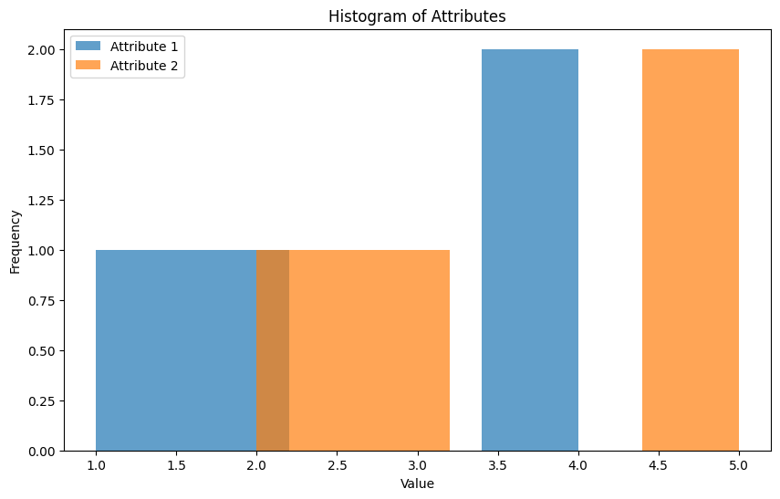
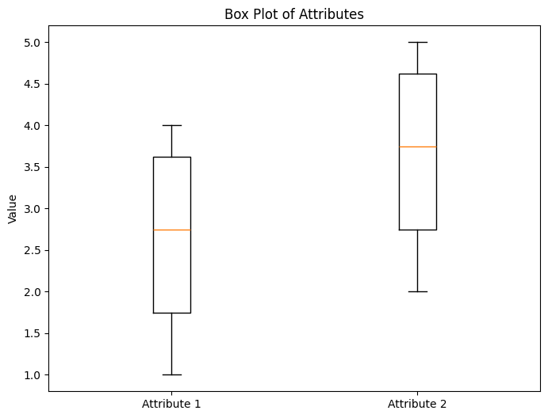
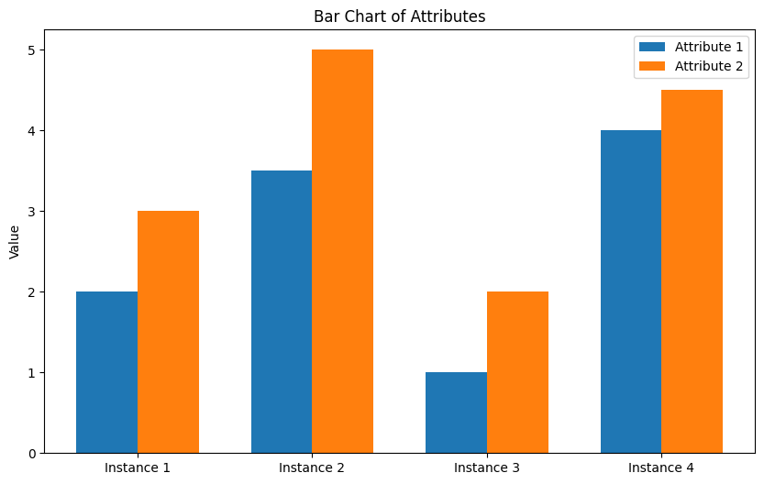
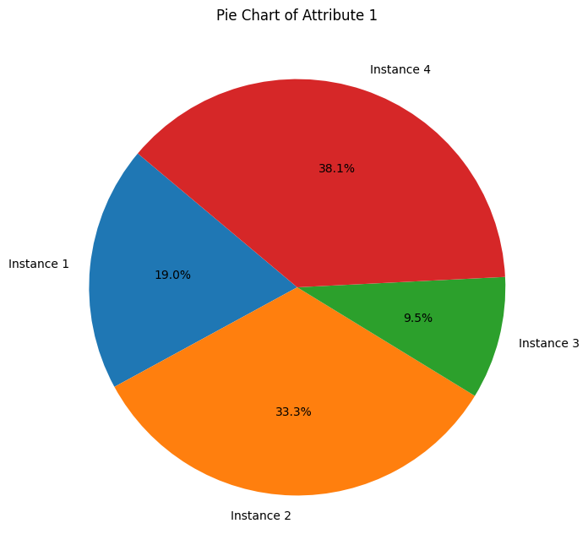

12.java apriori
import java.util.*;

public class apriori {
private List<Set<String>> transactions;
private double minSupport;

public apriori(List<Set<String>> transactions, double minSupport) {
this.transactions = transactions;
this.minSupport = minSupport;
}

public List<Set<String>> findFrequentItemsets() {
List<Set<String>> frequentItemsets = new ArrayList<>();
Set<String> items = new HashSet<>();

// Collect all unique items
for (Set<String> transaction : transactions) {
items.addAll(transaction);
}

// Generate initial candidates (single items)
List<Set<String>> candidates = new ArrayList<>();
for (String item : items) {
Set<String> singleItemSet = new HashSet<>();
singleItemSet.add(item);
candidates.add(singleItemSet);
}

// Iteratively find frequent itemsets
while (!candidates.isEmpty()) {
List<Set<String>> frequent = new ArrayList<>();
for (Set<String> candidate : candidates) {
int count = 0;
for (Set<String> transaction : transactions) {
if (transaction.containsAll(candidate)) {
count++;
}
}
double support = (double) count / transactions.size();
if (support >= minSupport) {
frequent.add(candidate);
frequentItemsets.add(candidate);
}
}
candidates = generateNextCandidates(frequent);
}

return frequentItemsets;
}

private List<Set<String>> generateNextCandidates(List<Set<String>> prevFrequent) {
List<Set<String>> nextCandidates = new ArrayList<>();
int size = prevFrequent.size();

for (int i = 0; i < size; i++) {
for (int j = i + 1; j < size; j++) {
Set<String> union = new HashSet<>(prevFrequent.get(i));
union.addAll(prevFrequent.get(j));
if (union.size() == prevFrequent.get(i).size() + 1) {
nextCandidates.add(union);
}
}
}

return nextCandidates;
}

public static void main(String[] args) {
List<Set<String>> transactions = new ArrayList<>();
transactions.add(new HashSet<>(Arrays.asList("milk", "bread")));
transactions.add(new HashSet<>(Arrays.asList("milk", "diaper", "beer", "bread")));
transactions.add(new HashSet<>(Arrays.asList("milk", "diaper", "beer", "cola")));
transactions.add(new HashSet<>(Arrays.asList("diaper", "beer", "bread")));
transactions.add(new HashSet<>(Arrays.asList("milk", "diaper", "bread", "beer")));

apriori ap = new apriori(transactions, 0.6);
List<Set<String>> result = ap.findFrequentItemsets();
System.out.println("Frequent Itemsets:");
for (Set<String> itemset : result) {
System.out.println(itemset);
}
}
}
Output:
Frequent Itemsets:
[diaper]
[beer]
[milk]
[bread]
[beer, diaper]
[diaper, milk]
[diaper, bread]
[beer, milk]
[beer, bread]
[bread, milk]
[diaper, beer, milk]
[diaper, beer, bread]
[diaper, beer, milk]
[diaper, beer, bread]
[beer, diaper, milk]
[beer, diaper, bread]
8.Simulated data set
import java.util.HashSet;
import java.util.Random;
import java.util.Set;

// Class to represent a single data instance
class DataInstance {
private int id;
private String name;

public DataInstance(int id, String name) {
this.id = id;
this.name = name;
}

public int getId() {
return id;
}

public String getName() {
return name;
}

@Override
public String toString() {
return "DataInstance [id=" + id + ", name=" + name + "]";
}

@Override
public boolean equals(Object obj) {
if (this == obj) return true;
if (obj == null || getClass() != obj.getClass()) return false;
DataInstance other = (DataInstance) obj;
return id == other.id;
}

@Override
public int hashCode() {
return id;
}
}

// Main class to generate and display unique data set
public class uniquedatasetgenerator {
public static void main(String[] args) {
int dataSize = 10; // number of data instances to generate
Set<DataInstance> uniqueDataSet = generateUniqueData(dataSize);

System.out.println("Generated Unique Data Set:");
for (DataInstance instance : uniqueDataSet) {
System.out.println(instance);
}
}

// Method to generate a set of unique DataInstance objects
public static Set<DataInstance> generateUniqueData(int size) {
Set<DataInstance> dataSet = new HashSet<>();
Random random = new Random();
String[] possibleNames = {
"Alice", "Bob", "Charlie", "David", "Eve",
"Frank", "Grace", "Heidi"
};

for (int i = 0; i < size; i++) {
int id = i + 1; // unique ID
String name = possibleNames[random.nextInt(possibleNames.length)];
DataInstance newInstance = new DataInstance(id, name);
dataSet.add(newInstance);
}

return dataSet;
}
}

Output:
Generated Unique Data Set:
DataInstance [id=1, name=Charlie]
DataInstance [id=2, name=Bob]
DataInstance [id=3, name=Grace]
DataInstance [id=4, name=Charlie]
DataInstance [id=5, name=Charlie]
DataInstance [id=6, name=Grace]
DataInstance [id=7, name=Heidi]
DataInstance [id=8, name=Bob]
DataInstance [id=9, name=Bob]
DataInstance [id=10, name=Alice]

